Final Report

## Introduction

### Project Overview

The project "Exploring Cyber Security: Understanding Threats and Solutions in the Digital Age" aims to analyze the evolving landscape of cyber threats and the strategies to mitigate them. It will explore various types of cyberattacks, such as malware, phishing, and ransomware, while highlighting preventive measures, security technologies, and best practices for safeguarding digital assets. The project also examines the role of individuals, organizations, and governments in maintaining cybersecurity.

### Purpose

The purpose of this project is to explore the evolving landscape of cybersecurity, identify common digital threats, and analyze effective solutions to mitigate risks. It aims to raise awareness of current cyber challenges and provide strategies for safeguarding digital environments. Ultimately, the project seeks to equip individuals and organizations with knowledge to strengthen their cybersecurity practices in the digital age.

## Ideation Phase

### Problem Statement

The rise of cyber threats like ransomware, phishing, and data breaches poses risks to individuals and organizations. Effective cybersecurity strategies are essential.

### Empathy Map Canvas

Understanding the mindset of users affected by cyber threats helps develop better security solutions.

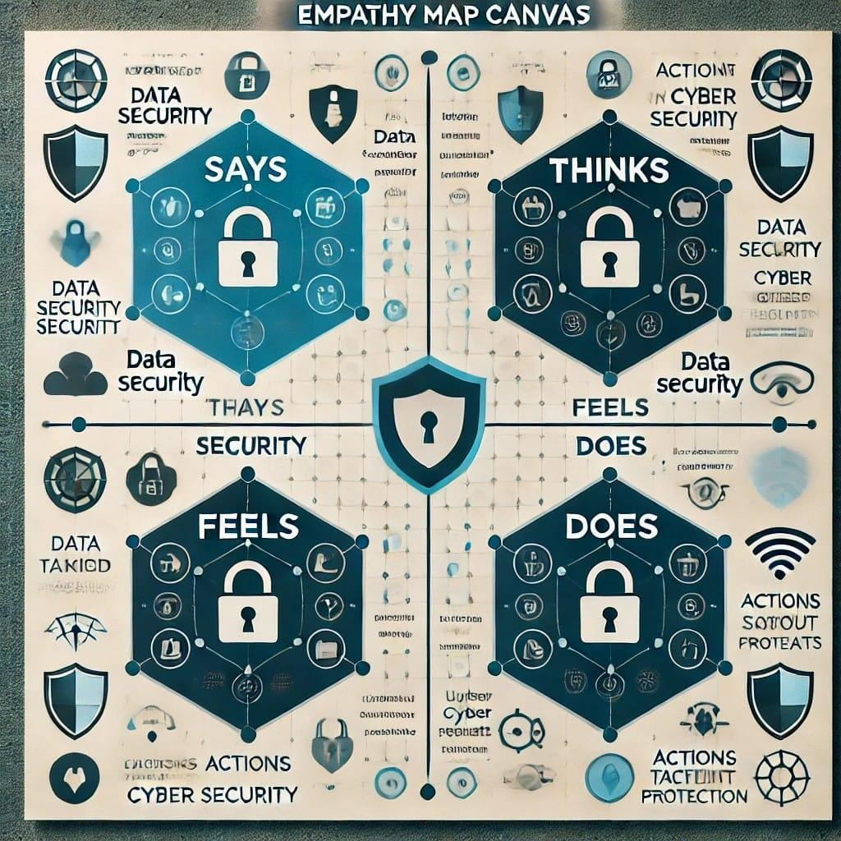

### Brainstroming

Phishing and smashing trends

Neha Hujare Ishwari Korbu

Analyzing the Evoiution of Ransomware

IOT

Vulnerabilities

Cloud

Security Breaches

Insider Threat

Deepfakes and Social

Engineering

The Threat of AI-Powered

cyberattacks

Jui Patil Nikita Mane

Zero Trust Security

Implementation

AI Driven Threat

detection

|  |  |  |  |  |
| --- | --- | --- | --- | --- |
| BlockChain for Cyber  Security | |  | Quantum  Cryptography | |
|  | Security Automation and Orchestration | | |  |

## Requirement Analysis

### Technology Stack:

Technologies such as AI, blockchain, and advanced encryption enhance cybersecurity.

# PROJECT DESIGN

### Problem Solution Fit:

Addressing cybersecurity vulnerabilities with innovative tools and strategies Problem- Solution Fit

### Proposed Solution

Implementing a multi-layered security approach combining threat detection, firewalls, and user awareness training.

### Solution Architecture

Designing a cybersecurity framework that integrates monitoring, prevention, and incident response



1. **Project planning**

|  |  |  |
| --- | --- | --- |
| **Day** | **Phase** | **Task** |
| 1-2 | Research | Study cyber threats and attack methods |
| 3-4 | Documentation | Write about key  cybersecurity concepts |
| 5-6 | Analysis | Case studies on real-world cyber attacks |
| 7-8 | Review | Proofreading and improving documentation |
| 9-10 | Finalization | Preparing project presentation / report |

# FUNCTIONAL AND PERFORMANCE TESTING

### Performance Testing

Evaluating the efficiency of cybersecurity measures in detecting and preventing cyber attacks.

## Results

* 1. **Screenshots (testing phase related)**

**Vulnerability scanning:**

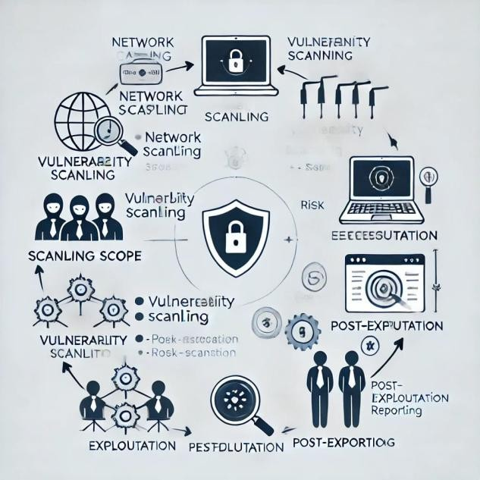

**Penetration Testing:**

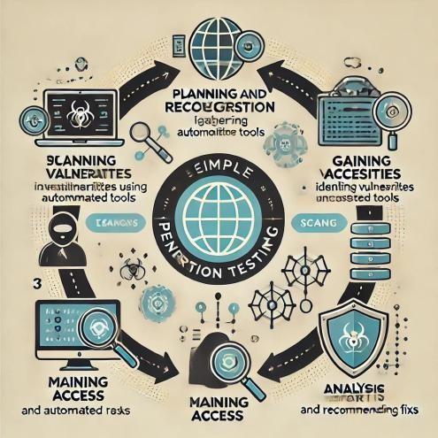

**Load Testing:**



# ADVANTAGES & DISADVANTAGES

### Advantages

* Enhanced data protection

– Reduced risk of cyber attacks

* Increased trust in digital systems

### Disadvantages

-High implementation costs

* Continuous need for updates
* Potential false positives in threat detection

# CONCLUSION

Cybersecurity is crucial in protecting digital assets. By implementing strong security measures and staying updated with emerging threats, individuals and organizations can mitigate cyber risks effectively.

# FUTURE SCOPE

Future cybersecurity developments include AI-powered threat detection, blockchain-based security, and enhanced biometric authentication.

## Appendix

* Source Code (if any)
* Dataset Link
* GitHub & Project Demo Link